# Exercise: Classes & Unit Testing on Classes

Problems for exercises and homework for the ["JavaScript Advanced" course @ SoftUni](https://softuni.bg/trainings/4227/js-advanced-september-2023). Submit your solutions in the SoftUni judge system at <https://judge.softuni.bg/Contests/2769/Classes-Exercise>

# Classes

## Rectangle

Write a **class** **Rectangle** for a rectangle object. It needs to have a **width** (Number), **height** (Number), and **color** (String) properties, which are set from the constructor, and a calcArea() method, that calculates and **returns** the rectangle’s area.

### Input

The constructor function will receive valid parameters.

### Output

The calcArea() method should **return** a number.

Submit the class definition as is, **without** wrapping it in any function.

### Examples

|  |  |
| --- | --- |
| Sample Input | Output |
| let rect = new Rectangle(4, 5, 'Red');  console.log(rect.width);  console.log(rect.height);  console.log(rect.color);  console.log(rect.calcArea()); | 4  5  Red  20 |

## Data Class

Write a **class** **Request** that holds data about an HTTP request. It has the following properties:

* method (String)
* uri (String)
* version (String)
* message (String)
* response (String)
* fulfilled (Boolean)

The first four properties (**method**, **uri**, **version**, **message**) are set through the **constructor**, in the listed order. The **response** property is initialized to undefined and the **fulfilled** property is initially set to false.

### Constraints

* The constructor of your class will receive **valid parameters**.
* Submit the class definition as is, **without** wrapping it in any function.

### Examples

|  |  |
| --- | --- |
| Sample Input | Resulting object |
| let myData = new Request('GET', 'http://google.com', 'HTTP/1.1', '')  console.log(myData); | Request {  method: 'GET',  uri: 'http://google.com',  version: 'HTTP/1.1',  message: '',  response: undefined,  fulfilled: false  } |

### Hints

Using ES6 syntax, a class can be defined similar to a function, using the class keyword:

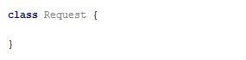

At this point, the **class** can already **be instantiated**, but it won’t hold anything useful, since it doesn’t have a constructor. A **constructor** is a function that **initializes** the object’s **context** and attaches **values** to it. It is defined with the keyword constructor inside the body of the class definition and it follows the syntax of regular JS functions - it can take **arguments** and execute **logic**. Any variables we want to be attached to the **instance** must be prefixed with this identifier:

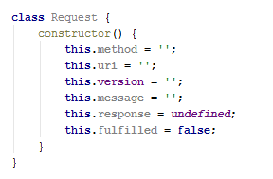

The description mentions some of the properties need to be set via the constructor - this means the constructor must receive them as parameters. We modify it to take four named parameters that we then assign to the local variables:

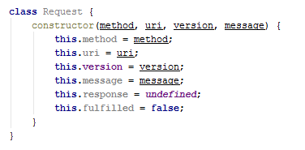

Note the input parameters have the same names as the instance variables - this isn’t necessary, but it’s easier to read. There will be no name collision because this identifier tells the interpreter to look for a variable in a different context, so this.method is not the same as the method.

Our class is complete and can be submitted to [Judge](https://judge.softuni.bg/Contests/Practice/Index/1534#0).

## Tickets

Write a program that manages a database of tickets. A ticket has a **destination,** a **price,** and a **status**. Your program will receive **two arguments** - the first is an **array of strings** for ticket descriptions and the second is a **string**, representing a **sorting criterion**. The ticket descriptions have the following format:

<destinationName>|<price>|<status>

Store each ticket and at the end of execution **return** a sorted summary of all tickets, sorted by either **destination**, **price,** or **status**, depending on the **second parameter** that your program received. Always sort in ascending order (the default behavior for **alphabetical** sort). If two tickets compare the same, use order of appearance. See the examples for more information.

### Input

Your program will receive two parameters - an **array of strings** and a **single string**.

### Output

**Return** a **sorted array** of all the tickets that were registered.

### Examples

|  |  |
| --- | --- |
| Sample Input | Output Array |
| ['Philadelphia|94.20|available',  'New York City|95.99|available',  'New York City|95.99|sold',  'Boston|126.20|departed'],  'destination' | [ Ticket { destination: 'Boston',  price: 126.20,  status: 'departed' },  Ticket { destination: 'New York City',  price: 95.99,  status: 'available' },  Ticket { destination: 'New York City',  price: 95.99,  status: 'sold' },  Ticket { destination: 'Philadelphia',  price: 94.20,  status: 'available' } ] |
| ['Philadelphia|94.20|available',  'New York City|95.99|available',  'New York City|95.99|sold',  'Boston|126.20|departed'],  'status' | [ Ticket { destination: 'Philadelphia',  price: 94.20,  status: 'available' },  Ticket { destination: 'New York City',  price: 95.99,  status: 'available' },  Ticket { destination: 'Boston',  price: 126.20,  status: 'departed' },  Ticket { destination: 'New York City',  price: 95.99,  status: 'sold' } ] |

## Sorted List

Implement a **class List**, which **keeps** a list of numbers, sorted in **ascending order**. It must support the following functionality:

* add(element) - adds a new element to the collection
* remove(index) - removes the element at position **index**
* get(index) - returns the value of the element at position **index**
* size - number of elements stored in the collection

The **correct order** of the elements must be kept **at all times**, regardless of which operation is called. **Removing** and **retrieving** elements **shouldn’t** **work** if the provided index points **outside the length** of the collection (either throw an error or do nothing). Note the **size** of the collection is **not** a function.

### Input / Output

All functions that expect **input** will receive data as **parameters**. Functions that have **validation** will be tested with both **valid and invalid** data. Any result expected from a function should be **returned** as its result.  
Your **add** and **remove** **functions** should **return** a **class** **instance** with the required functionality as its result.

Submit the class definition as is, **without** wrapping it in any function.

### Examples

|  |  |
| --- | --- |
| Sample Input | Output |
| let list = new List();  list.add(5);  list.add(6);  list.add(7);  console.log(list.get(1));  list.remove(1);  console.log(list.get(1)); | 6  7 |

## Length Limit

Create a class Stringer, which holds the **single string** and a **length** property. The class should be initialized with a **string** and an **initial length.** The class should always keep the **initial state** of its **given** **string**.

Name the two properties innerString and innerLength.

There should also be functional for increasing and decreasing the initial **length** property.  
Implement function increase(length) and decrease(length), which manipulate the length property with the **given value**.

The length property is **a numeric value** and should not fall below **0**. It should not throw any errors, but if an attempt to decrease it below 0 is done, it should be automatically set to **0**.

You should also implement functionality for toString() function, which returns the string, the object was initialized with. If the length of the string is greater than the **length property**, the string should be cut from right to left, so that it has the **same length** as the **length property**, and you should add **3 dots** after it if such **truncation** was **done**.

If the length property is **0**, just return **3 dots.**

### Examples

|  |
| --- |
| lengthLimit.js |
| **let *test*** = **new** Stringer(**"Test"**, 5); ***console***.log(***test***.toString()); *// Test* ***test***.decrease(3); ***console***.log(***test***.toString()); *// Te...* ***test***.decrease(5); ***console***.log(***test***.toString()); *// ...* ***test***.increase(4);  ***console***.log(***test***.toString()); *// Test* |

### Hints

Store the initial string in a property, and do not change it. Upon calling the toString() function, truncate it to the **desired value** and return it.

Submit your solution as a class representation only! No need for IIFEs or wrapping of classes.

## Company

**class** Company {  
 *//* ***TODO: implement this class...***  
}

Write a class **Company**, which following these requirements:

The **constructor** takes no parameters:

You could initialize an object:

* **departments** - empty object

addEmployee({name}, {salary}, {position}, {department})

This function should add a new employee to the **department with the given name**.

* If one of the passed parameters is an empty string (""), undefined or null, this function should **throw** an **error** with the following message: **"Invalid input!"**
* If salary is less than 0, this function should **throw** an **error** with the following message: **"Invalid input!"**
* If the new employee is hired successfully, you should add him into the **departments** object with the current name of the department and return the following message: **`New employee is hired. Name: {name}. Position: {position}`**

bestDepartment()

This functionshould return the **department** with the **highest average salary rounded** to the second digit after the decimal point and its **employees sorted** by their **salary** by **descending** order and by their **name** in **ascending** order as a second criterion:

**`Best Department is: {best department's name}**

**Average salary: {best department's average salary}**

**{employee1} {salary} {position}**

**{employee2} {salary} {position}**

**{employee3} {salary} {position}**

**…`**

### Submission

Submit only the **Company** class definition.

### Examples

This is an example of how the code is **intended to be used**:

|  |
| --- |
| Sample code usage |
| let c = new Company();  c.addEmployee("Stanimir", 2000, "engineer", "Construction");  c.addEmployee("Pesho", 1500, "electrical engineer", "Construction");  c.addEmployee("Slavi", 500, "dyer", "Construction");  c.addEmployee("Stan", 2000, "architect", "Construction");  c.addEmployee("Stanimir", 1200, "digital marketing manager", "Marketing");  c.addEmployee("Pesho", 1000, "graphical designer", "Marketing");  c.addEmployee("Gosho", 1350, "HR", "Human resources");  console.log(c.bestDepartment()); |
| Corresponding output |
| Best Department is: Construction  Average salary: 1500.00  Stan 2000 architect  Stanimir 2000 engineer  Pesho 1500 electrical engineer  Slavi 500 dyer |

## HEX

**class** Hex {  
 *//* ***TODO: implement this class...***  
}

Write a class **Hex**, having the following functionality:

* The **constructor** takes one parameter **value**, which is a number
* valueOf() This function should return the **value** property of the hex class.
* toString() This functionwill show its **hexadecimal value** starting with **"0x"**
* plus({number}) This function should add a number or Hex object and return a new Hex object.
* minus({number}) This function should subtract a number or Hex object and return a new Hex object.
* parse({string}) Create a **parse class method** that can **parse** Hexadecimal numbers and convert them to standard decimal numbers.

### Submission

Submit only your **Hex class.**

### Examples

This is an example of how the code is **intended to be used**:

|  |  |
| --- | --- |
| **Input** | **Output** |
| let FF = new Hex(255);  console.log(FF.toString());  FF.valueOf() + 1 == 256;  let a = new Hex(10);  let b = new Hex(5);  console.log(a.plus(b).toString());  console.log(a.plus(b).toString()==='0xF');  console.log(FF.parse('AAA')); | **0XFF**  **0XF**  **true**  **2730** |

# Built-in Collections

## Juice Flavors

You will be given different juices, as **strings**. You will also **receive quantity** as a **number**. If you receive a juice that you already have, **you must sum** the **current quantity** of that juice, with the **given one**. When a juice reaches **1000 quantity**, it produces a bottle. You must **store all produced bottles** and you must **print them** at the end.

**Note:** **1000 quantity** of juice is **one bottle**. If you happen to have **more than 1000**, you must make **as many bottles as you can**, and store **what** **is** **left** from the juice.

**Example:** **You have 2643 quantity** of Orange Juice – this is **2 bottles** of Orange Juice and **643 quantity left**.

### Input

The **input** comes as an array of strings. Each element holds data about a juice and quantity in the following format:

"{juiceName} => {juiceQuantity}"

### Output

The **output** is the produced bottles. The bottles are to be printed in the **order of obtaining the bottles**. Check the second example below - even though we receive the Kiwi juice first, we don’t form a bottle of Kiwi juice until the 4th line, at which point we have already created Pear and Watermelon juice bottles, thus the Kiwi bottles appear last in the output.

### Examples

|  |  |
| --- | --- |
| **Input** | **Output** |
| **['Orange => 2000',**  **'Peach => 1432',**  **'Banana => 450',**  **'Peach => 600',**  **'Strawberry => 549']** | **Orange => 2**  **Peach => 2** |
| **['Kiwi => 234',**  **'Pear => 2345',**  **'Watermelon => 3456',**  **'Kiwi => 4567',**  **'Pear => 5678',**  **'Watermelon => 6789']** | **Pear => 8**  **Watermelon => 10**  **Kiwi => 4** |

## Auto-Engineering Company

You are tasked to create a register for a company that produces cars. You need to store **how many cars** have been produced from a **specific model** of a **specific brand**.

### Input

The **input** comes as array of strings. Each element holds information in the following format:

"{carBrand} | {carModel} | {producedCars}"

The **carBrand** and **carModel** are **strings**, the **producedCars** are **numbers**. If the **carBrand** you’ve received **already exists**, just add the **new** **carModel** to it with the **produced cars** **as its value**. If even the **carModel** exists, just **add** the **given value** to the **current one**.

### Output

As **output**, you need to print - **for every car brand**, the **car models**, and a **number of cars produced** from that model. The output format is:

`{carBrand}

###{carModel} -> {producedCars}

###{carModel2} -> {producedCars}

...`

The order of printing is the order in which the brands and models first appear in the input. The first brand in the input should be the first printed and so on. For each brand, the first model received from that brand, should be the first printed and so on.

### Examples

|  |  |
| --- | --- |
| **Input** | **Output** |
| **['Audi | Q7 | 1000',**  **'Audi | Q6 | 100',**  **'BMW | X5 | 1000',**  **'BMW | X6 | 100',**  **'Citroen | C4 | 123',**  **'Volga | GAZ-24 | 1000000',**  **'Lada | Niva | 1000000',**  **'Lada | Jigula | 1000000',**  **'Citroen | C4 | 22',**  **'Citroen | C5 | 10']** | **Audi**  **###Q7 -> 1000**  **###Q6 -> 100**  **BMW**  **###X5 -> 1000**  **###X6 -> 100**  **Citroen**  **###C4 -> 145**  **###C5 -> 10**  **Volga**  **###GAZ-24 -> 1000000**  **Lada**  **###Niva -> 1000000**  **###Jigula -> 1000000** |

# Classes Interacting with DOM

The following problems must be solved using DOM manipulation techniques.

**Environment Specifics**

Please, be aware that every JS environment may **behave differently** when executing code. Certain things that work in the browser are not supported in **Node.js**, which is the environment used by **Judge**.

The following actions are **NOT** supported:

* **.forEach()** with **NodeList** (returned by **querySelector()** and **querySelectorAll()**)
* **.forEach()** with **HTMLCollection** (returned by **getElementsByClassName()** and **element.children**)
* Using the **spread-operator** (**...**) to convert a **NodeList** into an array
* **append()** in Judge (use only **appendChild()**)
* **prepend()**
* **replaceWith()**
* **replaceAll()**
* **closest()**
* **replaceChildren()**
* Always turn the collection into a **JS array** (forEach, forOf, et.)

If you want to perform these operations, you may use **Array.from()** to first convert the collection into an array.

## Contacts Builder

Write a JS **class** that generates a **contact** info box. You will receive a person's first name, last name, phone, and email. Compose the markup for the contact box, attach all the needed events, and when the **render** function is called, **append** the newly created element to the document.

A contact infobox is **composed** of first name, last name, phone, email (all strings), and property that indicates if the contact is online or not. Clicking a button on the box **toggles** the visibility of the person's contact information (phone and email). *See the examples for more details.*

The **constructor** of your class needs to take **four**-string arguments - first name, last name, phone, email. Additionally, the class should also contain the following functionality:

* Property online – Boolean value, initially set to **false**
* Function render(id)– **appends** the Contact's **HTML element representation** to the **DOM element** with **Id** equal to the argument

When the value of the online property is changed, the corresponding HTML should be updated – if it’s set to true, add the class "**online**" to the div with class "**title**" (containing the name). If it’s false, remove the class "**online**".

A contact info box should have the following HTML structure:

|  |
| --- |
| Contact |
| <**article**>  <**div class="title"**>{firstName lastName}<**button**>**&#8505;**</**button**></**div**>  <**div class="info"**>  <**span**>**&phone;** {phone}</**span**>  <**span**>**&#9993;** {email}</**span**>  </**div**>  </**article**> |

When the box is initially created, the div with class "**info**" must be **hidden**. Clicking the button **toggles its visibility**.

You can use the HTML skeleton to test your functionality.

**Hint:** Use <https://www.toptal.com/designers/htmlarrows/symbols/> to get Unicode escapes. (Example: Phone -> '\u260E').

### Examples

Your solution can be **tested** using the following code:

|  |
| --- |
| Sample JavaScript |
| let contacts = [  **new** Contact(**"Ivan"**, **"Ivanov"**, **"0888 123 456"**, **"i.ivanov@gmail.com"**),  **new** Contact(**"Maria"**, **"Petrova"**, **"0899 987 654"**, **"mar4eto@abv.bg"**),  **new** Contact(**"Jordan"**, **"Kirov"**, **"0988 456 789"**, **"jordk@gmail.com"**)  ];  contacts.forEach(c => c.render(**'main'**));  *// After 1 second, change the online status to true*  setTimeout(() => contacts[1].**online** = **true**, 2000); |

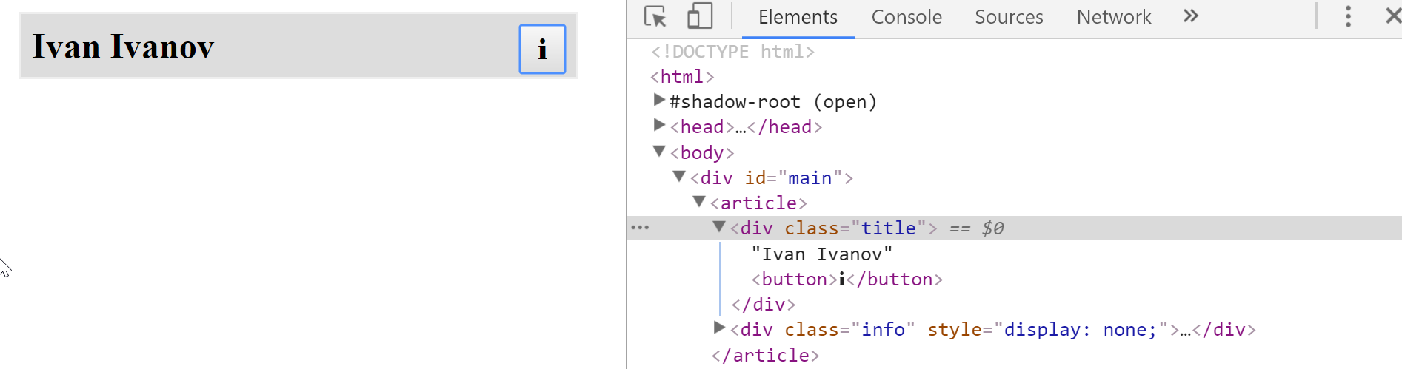

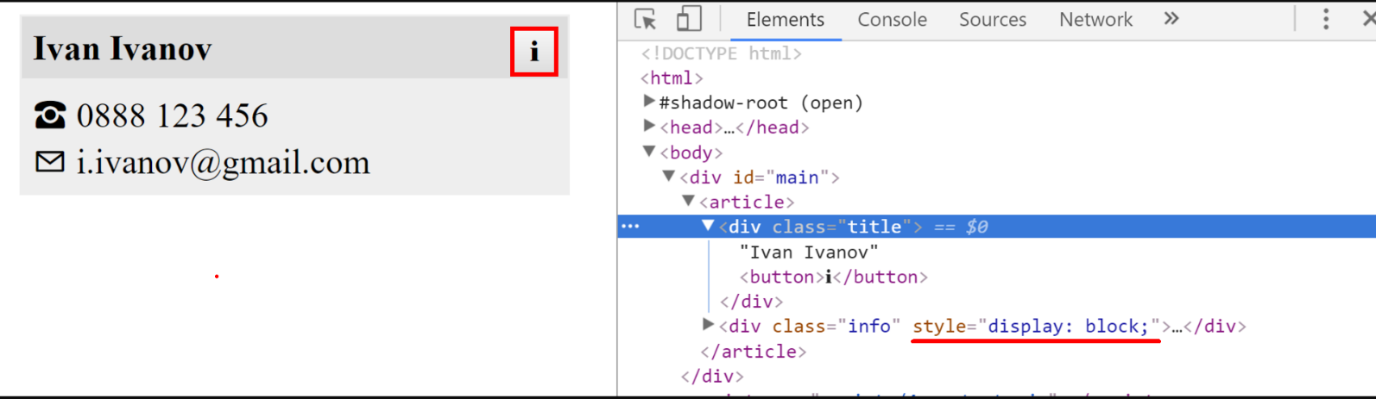

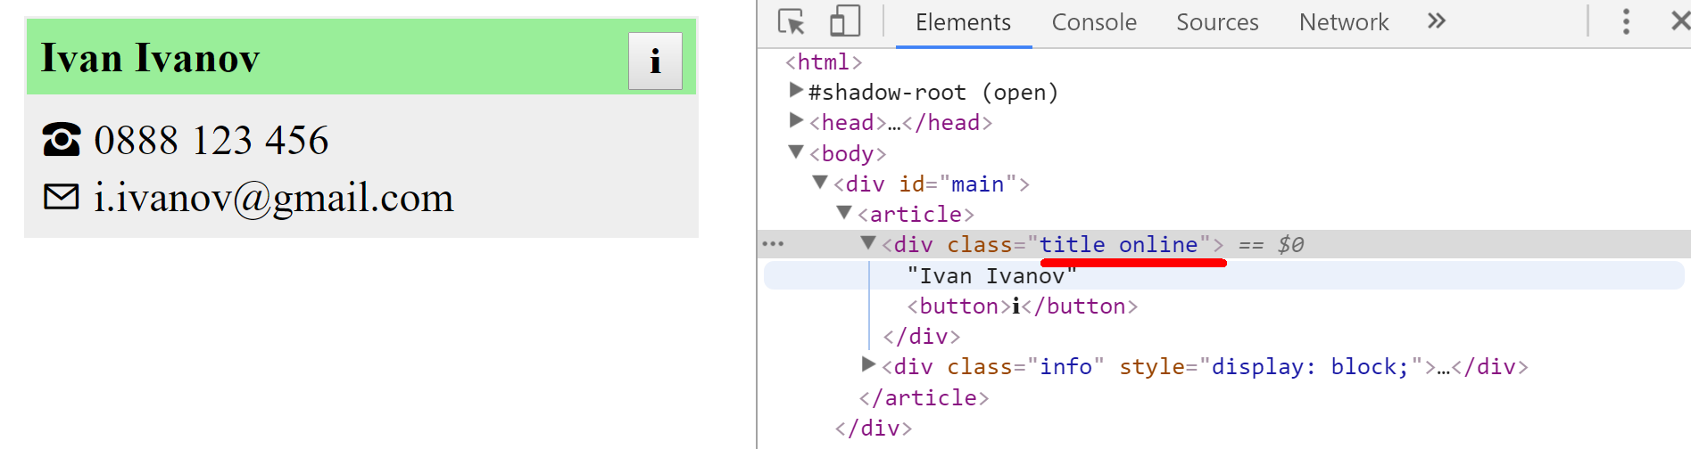

## View Model

We need to create a class Textbox that represents one or more **HTML input** elements with type="text". The constructor takes as parameters a **selector** and a **regex** for invalid symbols.

Textbox elements created from the class should have:

* property value (has getters and setters)
* property _elements containing the set of elements matching the selector
* getter elements for the _elements property – return as NodeList
* property _invalidSymbols - a regex used for validating the textbox value
* method isValid() - if the _invalidSymbols regex can be matched in any of the **_elements values** return false, otherwise, return true.

All _elements values and the value property should be linked. If the value of an element from _elements change all other elements' values and the value property should instantly reflect it, likewise should happen if the value property changes.

### Constraints

* Selectors will always point to input elements with type text.

### Example

To help you test your code, you're provided with an **HTML** template.

And an example **JS** **skeleton**.

Here is an example output in the browser:

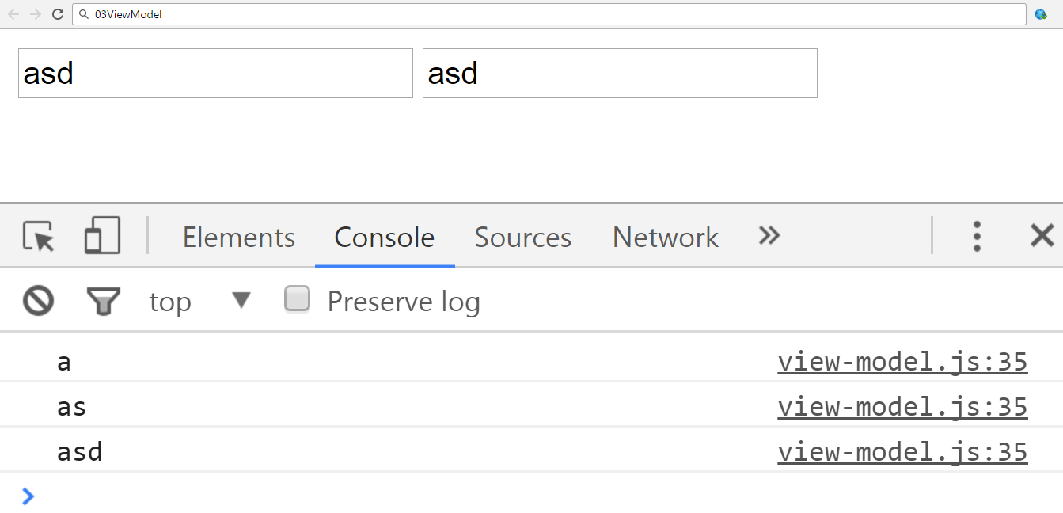

And the isValid function.

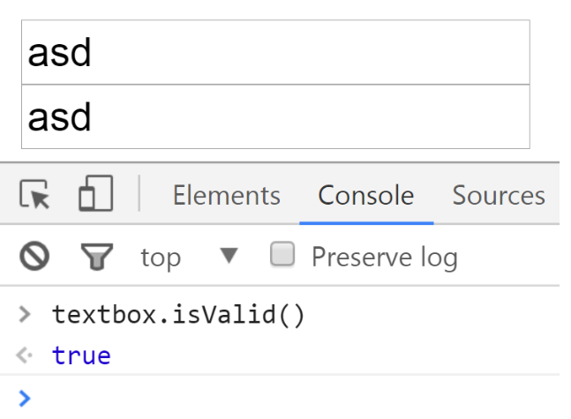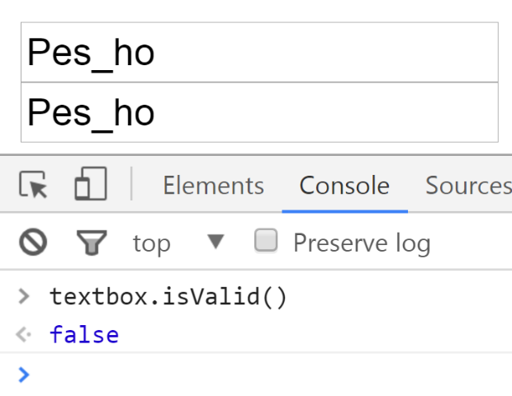

Submit only the Textbox class definition.

### Hints

* Pay attention to what event you use, different events trigger on different conditions. You want an event that is directly linked to changes in the value of an input element.
* Pay close attention to the value of this when writing event handler functions.

# Unit Testing on Classes

## Payment Package

You are given the following **JavaScript class**:

|  |
| --- |
| PaymentPackage.js |
| **class** PaymentPackage {  constructor(name, value) {  **this**.name = name;  **this**.value = value;  **this**.VAT = 20; *// Default value* **this**.active = **true**; *// Default value* }   **get** name() {  **return this**.**_name**;  }   **set** name(newValue) {  **if** (**typeof** newValue !== **'string'**) {  **throw new** Error(**'Name must be a non-empty string'**);  }  **if** (newValue.length === 0) {  **throw new** Error(**'Name must be a non-empty string'**);  }  **this**.**_name** = newValue;  }   **get** value() {  **return this**.**_value**;  }   **set** value(newValue) {  **if** (**typeof** newValue !== **'number'**) {  **throw new** Error(**'Value must be a non-negative number'**);  }  **if** (newValue < 0) {  **throw new** Error(**'Value must be a non-negative number'**);  }  **this**.**_value** = newValue;  }   **get** VAT() {  **return this**.**_VAT**;  }   **set** VAT(newValue) {  **if** (**typeof** newValue !== **'number'**) {  **throw new** Error(**'VAT must be a non-negative number'**);  }  **if** (newValue < 0) {  **throw new** Error(**'VAT must be a non-negative number'**);  }  **this**.**_VAT** = newValue;  }   **get** active() {  **return this**.**_active**;  }   **set** active(newValue) {  **if** (**typeof** newValue !== **'boolean'**) {  **throw new** Error(**'Active status must be a boolean'**);  }  **this**.**_active** = newValue;  }   toString() {  **const** output = [  **`Package:** ${**this**.name}**`** + (**this**.active === **false** ? **' (inactive)'** : **''**),  **`- Value (excl. VAT):** ${**this**.value}**`**,  **`- Value (VAT** ${**this**.VAT}**%):** ${**this**.value * (1 + **this**.VAT / 100)}**`** ];  **return** output.join(**'\n'**);  } } |

### Functionality

The above code defines a **class** that contains information about a **payment package**. An **instance** of the class should support the following operations:

* Can be **instantiated** with two parameters - a string name and number value
* Accessor name - used to get and set the value of the name
* Accessor value - used to get and set the value of value
* Accessor VAT - used to get and set the value of VAT
* Accessor active - used to get and set the value of active
* Function toString() - return a string, containing an overview of the instance; if the package is **not active**, append the label "**(inactive)**" to the printed **name**

When creating an instance, or changing any of the property values, the parameters are validated. They must follow these rules:

* name - non-empty string
* value - non-negative number
* VAT - non-negative number
* active - Boolean

If any of the requirements aren’t met, the operation must throw an error.

***Scroll down for examples and details about submitting to Judge.***

### Example

This is an example of how this code is **intended to be used**:

|  |
| --- |
| Sample code usage |
| *// Should throw an error* **try** {  **const *hrPack*** = **new** PaymentPackage(**'HR Services'**); } **catch**(err) {  **console**.log(**'Error: '** + err.**message**); } **const *packages*** = [  **new** PaymentPackage(**'HR Services'**, 1500),  **new** PaymentPackage(**'Consultation'**, 800),  **new** PaymentPackage(**'Partnership Fee'**, 7000), ]; **console**.log(***packages***.join(**'\n'**));  **const *wrongPack*** = **new** PaymentPackage(**'Transfer Fee'**, 100); *// Should throw an error* **try** {  ***wrongPack***.active = **null**; } **catch**(err) {  **console**.log(**'Error: '** + err.**message**); } |
| Corresponding output |
| Error: Value must be a non-negative number  Package: HR Services  - Value (excl. VAT): 1500  - Value (VAT 20%): 1800  Package: Consultation  - Value (excl. VAT): 800  - Value (VAT 20%): 960  Package: Partnership Fee  - Value (excl. VAT): 7000  - Value (VAT 20%): 8400  Error: Active status must be a boolean |

### Your Task

Using **Mocha** and **Chai** write **unit tests** to test the entire functionality of the PaymentPackage class. Make sure instances of it have all the required functionality and validation. You may use the following code as a template:

|  |
| --- |
| describe(**"*TODO* …"**, **function**() {  ***it***(**"*TODO …*"**, **function**() {  *//* ***TODO:*** …  });  *//* ***TODO:*** …  }); |

## String Builder *

You are given the following **JavaScript class**:

|  |
| --- |
| string-builder.js |
| **class** StringBuilder {  constructor(string) {  **if** (string !== ***undefined***) {  StringBuilder.*_vrfyParam*(string);  **this**.**_stringArray** = Array.from(string);  } **else** {  **this**.**_stringArray** = [];  }  }   append(string) {  StringBuilder.*_vrfyParam*(string);  **for**(**let** i = 0; i < string.**length**; i++) {  **this**.**_stringArray**.push(string[i]);  }  }   prepend(string) {  StringBuilder.*_vrfyParam*(string);  **for**(**let** i = string.**length** - 1; i >= 0; i--) {  **this**.**_stringArray**.unshift(string[i]);  }  }   insertAt(string, startIndex) {  StringBuilder.*_vrfyParam*(string);  **this**.**_stringArray**.splice(startIndex, 0, ...string);  }   remove(startIndex, length) {  **this**.**_stringArray**.splice(startIndex, length);  }   **static** *_vrfyParam*(param) {  **if** (**typeof** param !== **'string'**) **throw new TypeError**(**'Argument must be a string'**);  }   toString() {  **return this**.**_stringArray**.join(**''**);  } } |

### Functionality

The above code defines a **class** that holds **characters** (strings with length 1) in an array. An **instance** of the class should support the following operations:

* Can be **instantiated** with a passed in **string** argument or **without** anything
* Functionappend(string) - **converts** the passed in **string** argument to an **array** and adds it to the **end** of the storage
* Function **prepend**(**string**) - **converts** the passed in **string** argument to an **array** and adds it to the **beginning** of the storage
* FunctioninsertAt(string, index) - **converts** the passed in **string** argument to an **array** and adds it at the **given** index (you only need to test the behavior when the index is in range)
* Functionremove(startIndex, length) - **removes** elements from the storage, starting at the given index (**inclusive**), **length** number of characters (you only need to test the behavior when the index is in range)
* FunctiontoString() - **returns** a string with **all** elements joined by an **empty** string
* All passed in **arguments** should be **strings.** If any of them are **not**, **throws** a type **error** with the following message: **'Argument must be a string'**

### Example

This is an example of how this code is **intended to be used**:

|  |  |  |
| --- | --- | --- |
| Sample code usage |  | Corresponding output |
| **let** str = **new** StringBuilder(**'hello'**); str.append(**', there'**); str.prepend(**'User, '**); str.insertAt(**'woop'**,5 ); **console**.log(str.toString()); str.remove(6, 3); **console**.log(str.toString()); | User,woop hello, there  User,w hello, there |

### Your Task

Using **Mocha** and **Chai** write **JS unit tests** to test the entire functionality of the StringBuilder class. Make sure it is **correctly defined as a class** and instances of it have all the required functionality. You may use the following code as a template:

|  |
| --- |
| describe(**"*TODO* …"**, **function**() {  ***it***(**"*TODO …*"**, **function**() {  *//* ***TODO:*** …  });  *//* ***TODO:*** …  }); |